Hands-on Exercise No. 2 - DigiSkills 3.0 Batch-03 - AI Using Python
  - 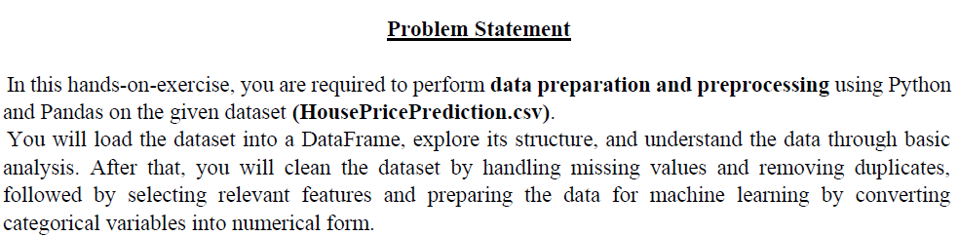
  - Step 1
  - 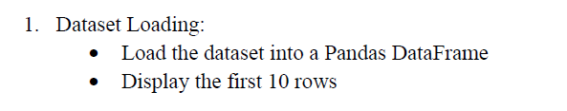
  - Code
  - 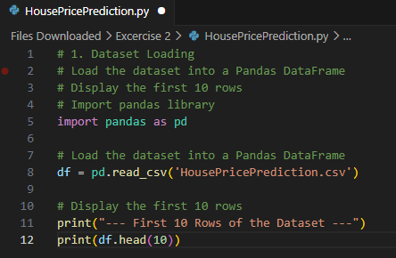
Output
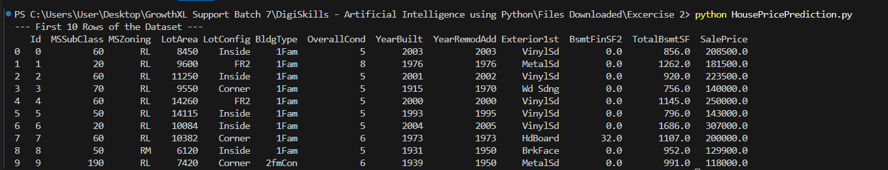
  - Step 2
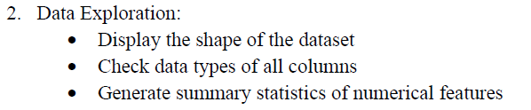
  - Code-2-a
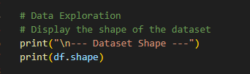
Output-2-a
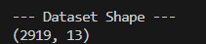

  - Code-2-b
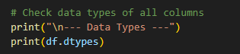
Output-2-b
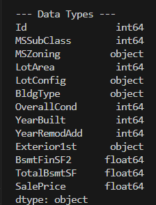

  - Code-2-c
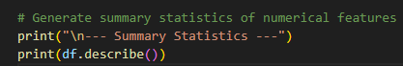

Output-2-c
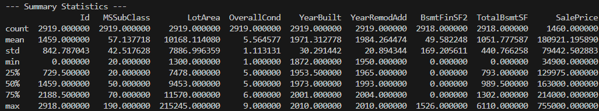
  - Step 3
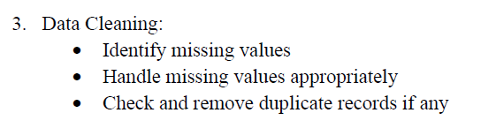

  - Code-3-a
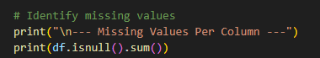

Output-3-a
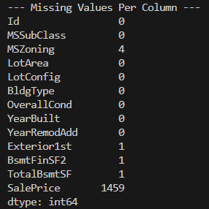
0 | Every house has data for the column above with 0 in front of the row
1 | There is one house in the entire dataset that is missing information for Exterior1st, BsmtFinSF2, and TotalBsmtSF.
4 | Four houses are missing the MSZoning classification.
1459 | SalePrice-1,459 rows have no price listed.
  - Code-3-b
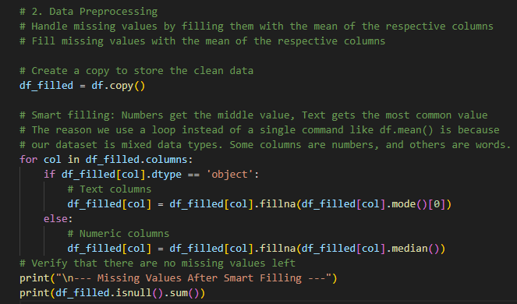

Output-3-b
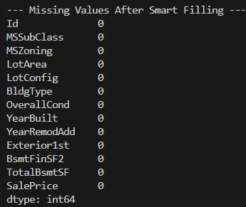
  - Code-3-c
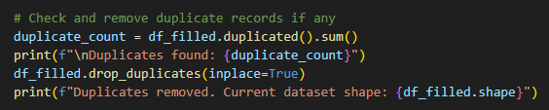
Output-3-c
  - Step 4
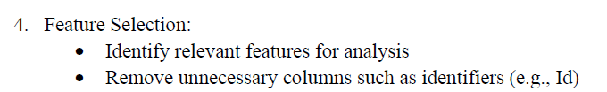
  - Code-4-a
We drop the “Id” column because it is simply a unique label for each row and contains no patterns that help predict in analysis.
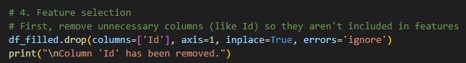
Output-4-a
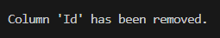

  - Code-4-b
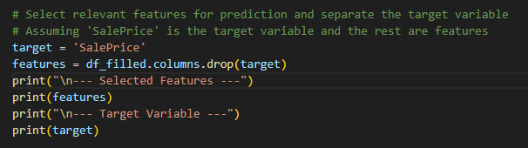
We identified “SalesPrice” as our target variable, which is the output we want the model to predict. Remaining columns are
designated as Features (aka data points)

Output-4-b
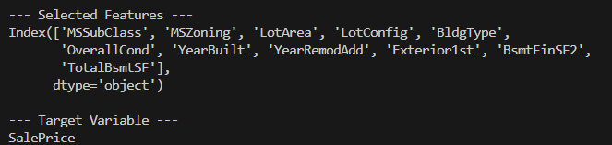

  - Step 5
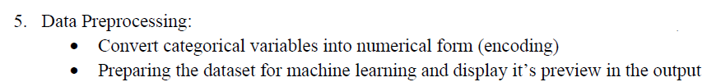
  - Code-5-a
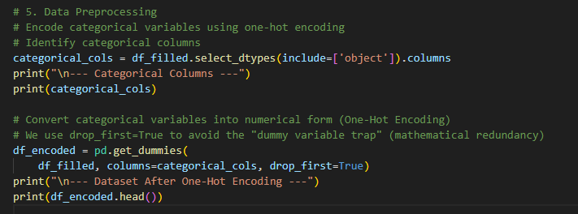
Output-5-a
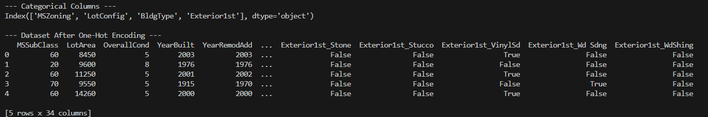
Created a separate data column for each category value, with entries marked as either “TRUE” or “FALSE”. i.e: What is the exterior made of? The category “Stone” is represented as “ExteriorIst_Stone”. Houses build with stone have this column with value “TRUE”.
  - Code-5-b
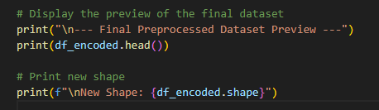

Output-5-b
